What Are True Leaves?
When a seed first emerges from the soil, or potting mixture, it has a set of two leaves called cotyledons. The cotyledons are actually a part of the seed, and act as a food source for the sprouting seedling. At this time the seedling does not conduct photosynthesis. It gets all its food and nutrition from the cotyledons.

As the seedling becomes stronger and healthier, it will begin to form two more leaves that look very different from the cotyledons. The true leaves will look more like what the plant’s leaves look like when mature. Once the true leaves are present, the plant is now actively photosynthesizing. Eventually the cotyledons will wither and fall off as the true leaves take over the job of feeding the plant.
Contributed by Charlotte Pollock from the Veggie Gardener website

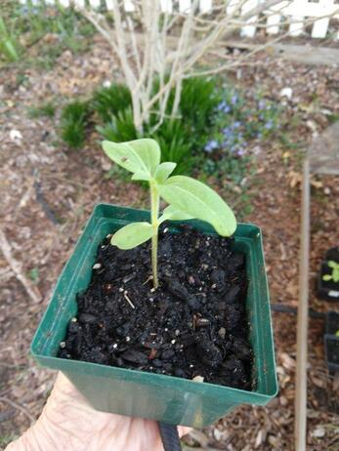
Sunflower with 4 true leaves and 2 cotyledons.
Photo by Charlotte

