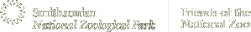
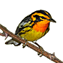
Smithsonian Migratory Bird Center
Hummingbird Nectar Recipe
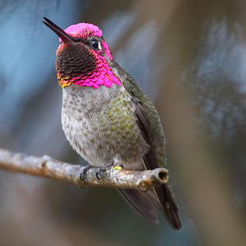
Directions for making safe hummingbird food:
- Mix 1 part sugar with 4 parts water and bring to a boil to kill any bacteria or mold present.
- Cool and fill feeder.
- Extra sugar water may be stored in a refrigerator.
- Red dye should not be added.
Related Resources
- All about Hummingbirds

