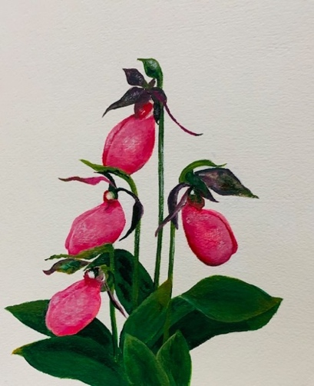
Membership Application

The Fairbanks Garden Club

Dedham, MA

Thank you for your interest in The Fairbanks Garden Club. New members are very welcome. The Fairbanks Garden Club is dedicated to promoting horticultural education, protecting wildlife and natural plant life, and enhancing horticultural beauty in our community.

In addition to maintaining gardens at the Fairbanks House, which includes our award-winning colonial herb garden and a pollinator garden, the club maintains the plantings at two historical markers in Dedham, decorates and donates holiday wreaths for local institutions, and holds an annual plant sale. Each member is expected to participate in the annual plant sale and to join a committee.

Regular meetings are held from September through May (except January) beginning at 11:30 AM on the third Wednesday of each month at the Endicott Estate, 656 East Street, Dedham, MA, unless otherwise noted in our Yearbook. Your annual dues provide for a monthly buffet luncheon, professional guest speakers, and fun workshops.

Please complete and return this application, along with your check for $50, made payable to
Fairbanks Garden Club.
Mail: Dr. Saroj Joshi, Membership Chairperson, 7 Egan Terrace, Dedham, MA 02026
Email: saroj.joshi@rcn.com

Name: ______________________________________________________________________________

Address: ____________________________________________________________________________

Cell Phone Number: ___________________________________________________________________

Home Phone Number: _________________________________________________________________

Email: ______________________________________________________________________________

