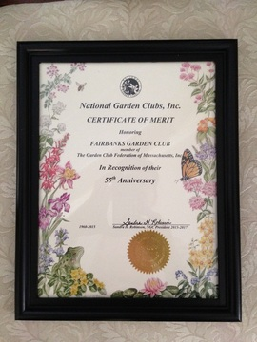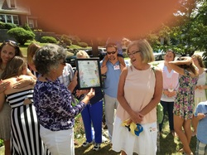

55 Years Old and Still Going Strong
Our club celebrated its 55th Anniversary at the 2015 Fairbanks Family in America Reunion.

Garden Club Co-President Christine Page presents the plaque to Tina Blood, President of the Fairbanks Family in America, Inc.

